Mobile Programming: Kalkulate mobile banking application

Christian Medrano

4/29/2024

Main Components:

* Bank Account class

A bank account creates and manages a Savings and Checking account, allowing money transfers from checking to savings, and from savings to checking accounts.

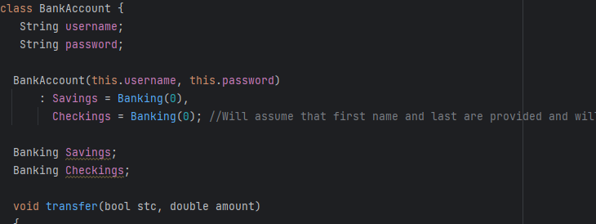

* Banking Class

Banking class is used in every Bank account class as a savings and checking, allowing deposits and transactions.

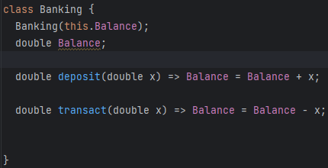

* Bank

Bank is a List created to hold every instance of a Bank account, within each bank account is an account with a unique username and password, and each with a checking and savings account.



* Login Page

Login Page is a simple Page which asks the user for a username and password. Using these, an account is created, but only if the username and password are unique. After the account is created, it is added to the bank list.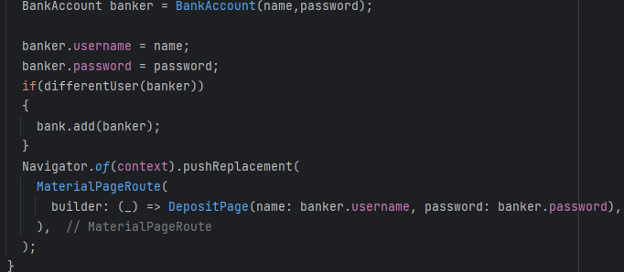

* Admin Page

Admin Page is a page where we display the contents of the bank list, showing every account name, savings and checking balance, and password. This page is here to track the passwords and usernames of every account created, and neatly display their balances.

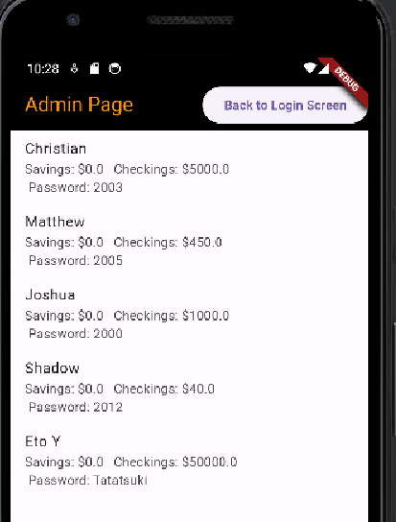

* Deposit page

The main page of the application, in charge of operating and logging the transactions that have recently occurred on page. Every bank account will be accessible on this page, past transactions are applied to accounts, and balances are well logged.

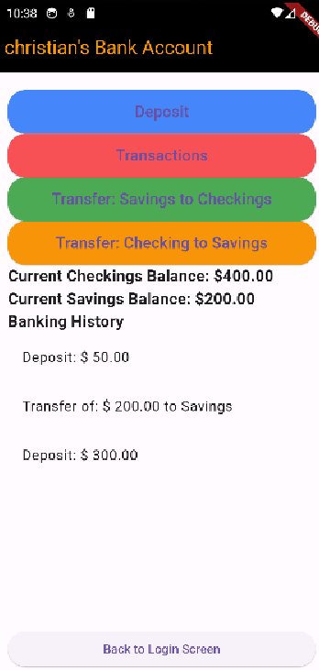

Use Cases:

* Creating bank accounts

In order to create an account, one must simply log in with a username and password from the Login menu. This will automatically create a bank account object for you and add it to the Bank log, with your selected password and username.

* Logging into created bank accounts

In order to log into a created bank account, one must enter the username and password of an already existing account, the bank account class method different User will automatically find the account and assign the bank to the correct index. If no index is found, that means that a new bank account is created, and the index will be set to that account's index.

* Logging bank transactions

Using a List, we keep track of the user's past transaction when accessing their bank account, these transactions are all applied using the functions defined in the bank account class.

* Administrator Bank database

Using a List, we keep track of all created bank accounts information, this includes their username and password, and their current balances, and display their information.